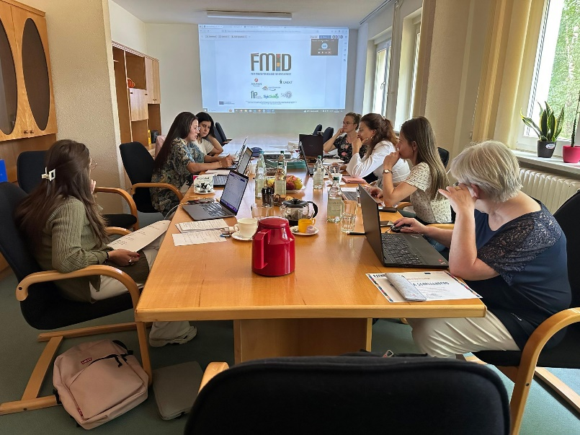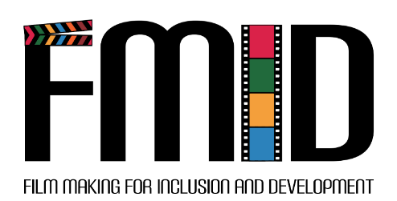

FINAL CONFERENCE

On June 16th, the final event took place in the international leisure and educational center "lütt pütt" of the Jugendförderverein. The project results were presented in cinema style with popcorn and cotton candy. The films shot by yo ung people in the project were also shown. There were information booths where attendees could learn more about the areas of filmmaking: film capture and editing, sound recording and editing, storytelling, reels and online self-expression, selfie sticks and ring lights for better shots and much more. The event was well attended with over 60 participants.

In this newsletter you will learn more about:

* Project development up to date
* Third transnatioinal meeting
* Final conference

WHAT HAS BEEN DONE?

**Video-making resources for employability and development of young people –** Resources are finished and translated into all partner languages. Using them, young people created high-quality videos focusing on the employability, self-development, and entrepreneurship perspective

**In-service training programme and handbook for youth educators -** Youth workers and educators have been trained to support young people in their area.

**E-learning portal** – All resources are available and free in all partner languages.

PROJECT MEETING IN PARCHIM

Consortium members met at the third Transnational Partner Meeting that was held in Parchim on June 14th – 15th to discuss the next steps in project development. At the meeting, each partner had the opportunity to discuss the results of the film festival conducted in their countries. In addition, the consortium agreed on the final tasks and deadlines needed.

YOU CAN FIND US ON FACEBOOK  
<https://www.facebook.com/FMIDproject/>  
AND ON OUR PROJECT WESITE:  
<https://fmid.eu/>

# WELCOME TO THE 3rd NEWSLETTER OF THE FMID PROJECT!

JUNE 2023